
MSUNDUZI MUNICIPALITY COUNCILLORS
WARD COUNCILLORS
WARD | NAME | CONTACT DETAILS
 | MSOMI KHULEKANI (ANC) | 073 304 5375  *4686 | 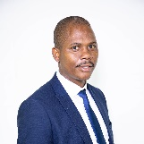
 | MBONGENI ZUMA (ANC) | 0715480665 | 
 | MAKHAYE SKHANYISO CYRIL (ANC) | 072 110 7893  *4151  Skhanyiso.Makhaye@msunduzi.gov.za | 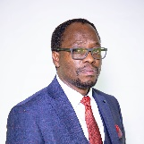
 | ZONDI HAMILTON MLUNGISI (ANC) | 083 947 2453  *4684  Mlungisi.Zondi@msunduzi.gov.za | 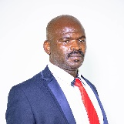
 | MBANJWA NKOSINATHI MAXWELL (ANC) | 071 366 0106  *4685  Nkosinathi.Mbanjwa@msunduzi.gov.za | 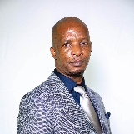
 | MADONDA KWAZIKWAKHE EMMANUEL (ANC) | 079 938 3650  *4512 | 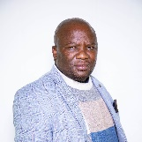
 | ZUMA BUKELANI EPHRAM (IND) | 072 098 4796  *4513  Bukelani.Zuma@msunduzi.gov.za | 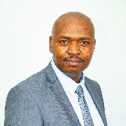
 | NGUBANE MSHUSHISI AUBREY (IFP) | 073 983 8723  *4687 | 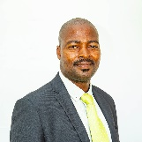
 | MSHENGU MDUDUZI CASWELL (ANC) | 082 542 7721  *4689 | 
 | NGUBANE THEMBA CYRIL (ANC) | 067 236 7078  *4690  thembangubane09@gmail.com | 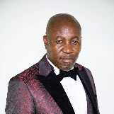
 | ZUMA SANELE RUSSEL (ANC) | 065 979 8890  *4515 | 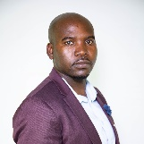
 | MASOEU NKOSINATHI PATRICK (ANC) | 081 403 6406  *4516 | 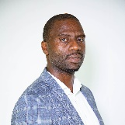
 | MNCWANGO GLADNESS SIBONGILE (ANC) | 072 438 5931  *4691  Gladness.Mncwango@msunduzi.gov.za | 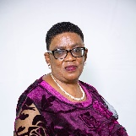
 | MKHIZE SIBUSISO ALFRED (ANC) | 084 425 8533  *5155  stofu24@gmail.com | 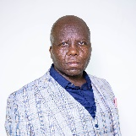
 | BHENGU MSAWENKOSI (ANC) | 073 972 0584  *4710 | 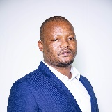
 | ZUMA MICHEAL BHEKABANTU (ANC) | 078 251 4585  *4693  Micheal.Zuma@msunduzi.gov.za | 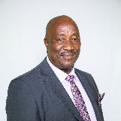
 | NDLOVU MPHILISI INSTANCE (ANC) | 084 729 4689  *4752 | 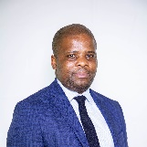
 | BUTHELEZI SIMPHIWE SAMUEL (ANC) | 081 443 4502/ 073 544 0816  *5124  Simphiwe.Buthelezi@msunduzi.gov.za | 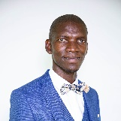
 | NGWENYA PERCIVAL VUSI (ANC) | 072 223 5733  *4712  Percival.Ngwenya@msunduzi.gov.za | 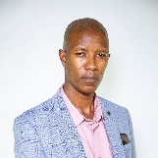
 | PHUNGULA SIPHIWE (ANC) | 060 438 0982  *4719 | 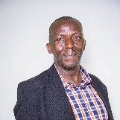
 | ZUMA SBONGUMUSA (ANC) | 079 342 8026  *4519  Sbongumusa.Zuma@msunduzi.gov.za | 
 | ZONDI THEMBINKOSI (ANC) | 082 428 9088  *4695  tzzondi@gmail.com | 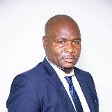
 | PHUNGULA DUMISANI BERNARD (ANC) | 083 328 8328  *4696  Dumsani.Phungula@msunduzi.gov.za | 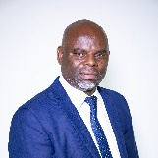
 | NKABINI SINOTHI JEROME (ANC) | 082 403 4562  *4699  Jerome.Nkabini@msunduzi.gov.za | 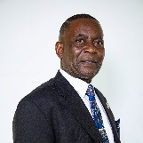
 | KHANYILE REGINALD XOLANI (DA) | 081 770 5129 | 
 | STRACHAN ROSS BRYAN (DA) | 076 882 8101  *4697  Ross.Strachan@msunduzi.gov.za | 
 | KEMP HAROON DANIEL (DA) | 081 788 2528  *4520  Daniel.Kemp@msunduzi.gov.za | 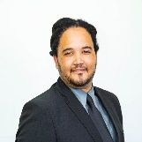
 | RENISHA SINGH (DA) | 068 112 5102 | 
 | MADLALA SPHAMANDLA SYDNEY  (ANC) | 084 019 1397  *4705 | 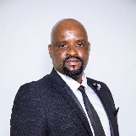
 | SOOBIAH RACHEL (DA) | 084 809 2326  *4717  Racheal.Soobiah@msunduzi.gov.za | 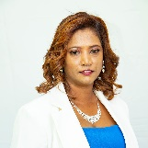
 | AHMED ROOKSANA (DA) | 065 802 8728  *4708  Rooksana.Ahmed@msunduzi.gov.za | 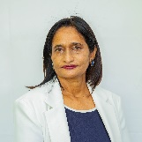
 | MIDDLETON GARTH FREDERICK WESLEY (DA) | 073 515 0970  *4701 | 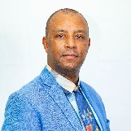
 | REDDY SURAYA (DA) | 084 508 5130  *4703  Suraya.Reddy@msunduzi.gov.za | 
 | RAM ROY (ANC) | 082 551 4663  *4518 | 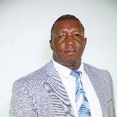
 | DLAMINI SANDILE WELLINGTON (ANC) | 072 848 3587  *4714  Sandile.Dlamini@msunduzi.gov.za | 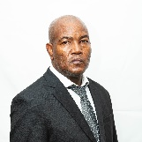
 | ROBERTS DOUGLAS LESLIE (DA) | 081 375 9338  douglas.denise@telkomsa.net | 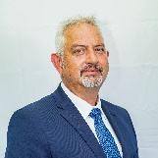
 | ELLIOTT EDITH (DA) | 082 415 9435  Elliottt.edith018@gmail.com | 
 | DLAMINI GODMAN NKOSIVELILE (ANC) | 079 012 0162  Godman.Dlamini@msunduzi.gov.za | 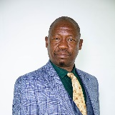
 | MKHIZE MBUSISWA HENCEFORT (ANC) | 078 830 9311  Mbusiswa.Mkhize@msunduzi.gov.za | 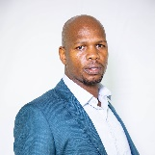
 | NGUBO JABULISILE JOYCE (ANC) | 071 606 0103  *4524  Jabulisile.Ngubo@msunduzi.gov.za | 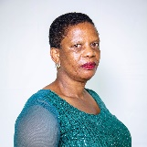
 | ZUMA BUSANI EDWARD (ANC) | 0672970466  *5144 | 


MSUNDUZI MUNICIPALITY: COUNCILLORS 2021/2026

PR COUNCILLOURS EXCO
NO | NAME | CONTACT DETAILS
 | (The Mayor)  THEBOLLA MZIMKHULU MESHACK (ANC) | 083 408 1551  *5121  Thebolla.Mzimkhulu@msunduzi.gov.za | 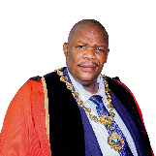
 | (The Deputy Mayor)  MKHIZE MXOLISI THEOPHILUS (ANC) | 073 246 3331  *4171  ngaphezulu@gmail.com | 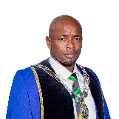
 | NGCOBO ZANELE PRINCESS (ANC) | 082 836 7319  *5110  Zanele.Msunduzi@msunduzi.gov.za | 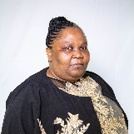
 | MSIMANG NOKUTHULA PRUDENCE (ANC) | 078 620 1867  *4718  Nokuthula.Msimanga2msunduzi.gov.za | 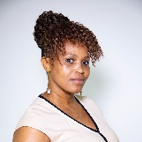
 | SOKHELA NTOMBIZETHU PRECIOUS (ANC) | 073 513 2664  *4017 | 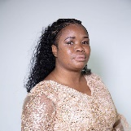
 | NHLABATHI BONGUMUSA CYRIL (DA) | 079 613 1056  *4702  Bongumusa.Nhlabathi@msunduzi.gov.za | 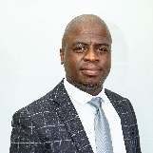
 | STRACHAN ROSS BRYAN (DA) | 076 882 8101  *4697  Ross.Strachan@msunduzi.gov.za
 | NTOMBELA THINASONKE DENNIS (IFP) | 082 432 9396  *5149  Thinasonke.Ntombela@msunduzi.gov.za | 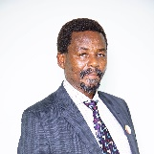
 | PHAHLA PHUMELELE (ABC) | 060 501 8273  Londeka.mshengu@msunduzi.gov.za | 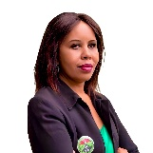
 | WAKENI CHUMA (EFF) | 0796771835  cwakeni10@gmail.com  Chuma.Wakeni@msunduzi.gov.za
SPEAKER, CHIEF WHIP AND MPAC
 | (The Speaker)  MAJOLA NOMAGUGU EUNICE (ANC) | 071 156 7427  *4594  Nomagugu.Majola@msunduzi.gov.za | 
 | (The Chief Whip)  DLAMINI SANDILE WELLINGTON (ANC) | 072 848 3587  *4714  Sandile.Dlamini@msunduzi.gov.za
 | (MPAC Chair)  MAGUBANE ZWELINJANI HENRY(IFP) | 072 566 7105  *4531 | 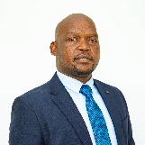
PR COUNCILLOURS
 | DLAMINI THOLAKELE IGNETIA (ANC) | 072 212 3375  *5160  Tholakele.Dlamini@msunduzi.gov.za | 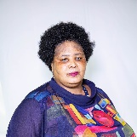
 | MKHIZE DORCAS SIBONGILE (ANC) | 083 331 3170  *4707 | 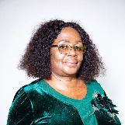
 | SITHOLE PHILISIWE (ANC) | 072 398 5852  *4711  Philisiwe.Sithole@msunduzi.gov.za | 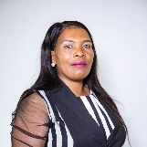
 | PHUNGULA VICTORIA MAVIE (ANC) | 076 070 6202  *5168 | 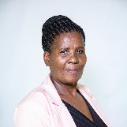
 | MKHIZE THANDIWE (ANC) | 084 365 0015 | 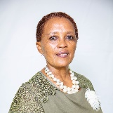
 | LYNE SANDRA PATRICIA (DA) | 082 896 5264  *5177 | 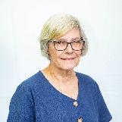
 | MGAGA LUNGILE (DA) | 072 277 2106  Lungile.mgaga@msunduzi.gov.za
 | NGUBO ZINHLE (DA) | 074 045 5089  *5169 | 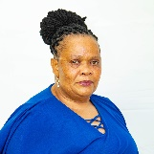
 | SIBUSISO DESMOND CHONCO (DA) | 083 364 5968  *4720  Sibusiso.Chonco@msunduzi.goc.za | 
 | PHUNGULA NOMATHEMBA (DA) | 072 933 4641 | 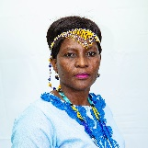
 | MAPHANGA PRETTY NELISIWE (IFP) | 071 284 7218 | 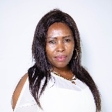
 | NTOMBELA THANDANAM DESMOND (IFP) | 082 383 9237 | 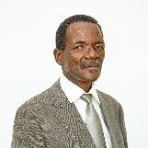
 | NDLOVU NOMFUNDO (IFP) | 082 811 9752
 | SHEZI MBONGENI JETRO (IFP) | 073 361 4756 | 
 | MAHOMED SHAMEEL RAHMAN (IFP) | 0798058791 | 
 | GCABASHE SANDILE (ABC) | 084 081 6954
 | NIEMAND REINUS (ACDP) | 076 289 0982  *4763  Rienus.Niemand@msunduzi.gov.za
 | DLELA NOMALADY ELEANOR (AIC) | 068 297 3536 | 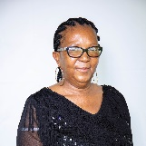
 | NDLOVU SINENHLANHLA LOVE-JOY (JEP) | 072 503 1338  cneshamase@gmail.com
 | ADAMS RANDAL JOHN (PA) | 072 213 3175  Sagewise1322@gmail.com
 | MKIZE BEATRICE NOMBUYISELO (EFF) | 073 117 7938 | 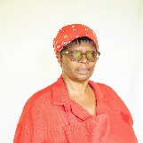
 | MNCWABE STANLEY NTUTHUKO (EFF) | 072 010 6249 | 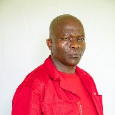
 | CELE THOLAKELE NELISIWE (EFF) | 076 015 8819 | 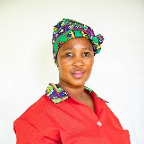
 | MBONA BONGANI DUM’SANI (EFF) | 078 627 7784  mpungashe@gmail.com | 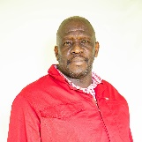
 | NGCOBO AYANDA BRENDA (EFF) | 079 110 5520
 | MNCUBE NOMUSA WENDY (EFF) | 071 032 4930 | 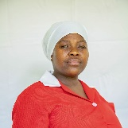
 | SITHOLE SIBONISO (EFF) | 061 456 1253
 | MPULO SANELE PROTAS (EFF) | 063 702 6418 | 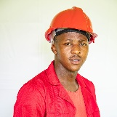
 | MZILA THEMBILE PRECIOUS MEMORY (EFF) | 065 507 7003  Thembile.Mzila@msunduzi.gov.za

